WORKSHEET – 1

**Student Name: Sandeep Kumar UID: 20BCS4885**

**Branch: CSE Section/Group: 48/A**

**Semester: Third semester Date of performance: 10/09/2021**

**AIM:** Write a program to study different types of constructors in java.

# Code:

import java.util.Scanner; class Default{

Default()

{

System.out.print("Constructor with no parameters"); System.out.println();

System.out.print("Drop Student Details (UID)\n");

}

}

class Parameterised {

Parameterised(String UID, String StuName)

{

System.out.print("Constructor with parameters"); System.out.println(); System.out.print("Student name is \n"+StuName+"\nStudent UID is \n"+UID);

}

}

public class constructor {

public static void main(String[] args)

{

// Object for default constructor Default Default_Object = new Default(); Scanner input = new Scanner(System.in); System.out.print("Student Name:\n"); String name = input.next(); System.out.print("Student Uid:\n"); String uid = input.next();

// Object creation of Parameterised construtor

Parameterised Parameterised_object = new Parameterised(uid,name);

// string private class

}

}

**Output:**

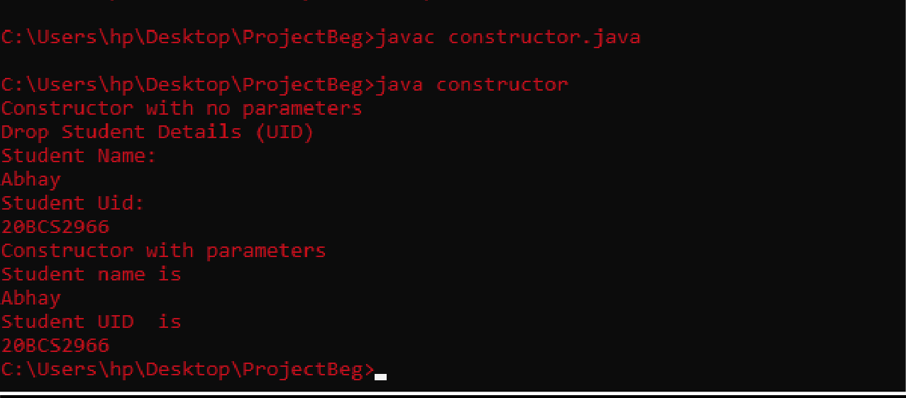

**=============================== Thanks ==========================**